**Optimizing Job Sequencing and Machine Utilization in a Manufacturing Process**

**Manufacturing Resource Analysis**

**Grishma Koirala**

**S02041516**

**April 25, 2023**

# **Introduction**

Job scheduling is the process of assigning tasks or jobs to resources in a manufacturing system in a way that maximizes efficiency and minimizes waste. It involves deciding which job to process next, considering factors such as job priority, resource availability, and job characteristics such as arrival time, processing time, and due date. The objective of job scheduling is to ensure that resources are utilized optimally and that production processes are completed in a timely manner. By effectively managing job scheduling, organizations can improve productivity, reduce lead times, and increase efficiency.

This project focuses on developing an Excel spreadsheet to track the progress of plastic injection mold jobs through a process-oriented manufacturing facility. The lack of job tracking currently in place at the local manufacturer has resulted in missed delivery dates, impacting customer satisfaction and ultimately, the company's bottom line. The importance of this study lies in the potential for the implementation of an effective production scheduling system to optimize job flow, improve on-time delivery rates, and increase overall productivity. By utilizing lean tools, the project aims to identify and eliminate waste within the manufacturing process, leading to increased efficiency and cost savings. The expected results of this report are the implementation of an Excel-based production scheduling system that enables real-time tracking of job progress, increased on-time delivery rates, and improve overall production efficiency. The use of lean tools should also help identify areas of waste and opportunities for process improvement, further enhancing the manufacturer's ability to meet customer demands and remain competitive in the industry.

# **Methods**

The methodology used in this project involves the creation of a dynamic Excel spreadsheet template that allows for the tracking of job progress in a plastic injection mold manufacturing facility. The first step involves selecting dispatching rules to be used for job scheduling, which include First Come, First Served (FCFS), Earliest job Due Date (EDD), and Shortest Process Time (SPT).

To implement these dispatching rules, the project utilizes Johnson's rule as an example. Johnson's rule is used to minimize the total time of completing a number of jobs, and it also reduces the number of idle times between the two work centers. The dynamic Excel spreadsheet templates are created using Excel functions and basic formulas. These templates are designed to automatically update results when changes are made to the source data.

The next step involves creating a trigger for the associated tables that follow different scheduling rules. This is done by using the SMALL function to determine the job sequence in the corresponding column. Once the job sequence is determined, the INDEX/MATCH function is used to implement the dynamic data connection between the source table and the associated tables that are resorted based on the scaling parameters of different sequencing rules.

Overall, this methodology allows for the implementation of a dynamic Excel spreadsheet template that optimizes job flow, improves on-time delivery rates, and increases overall productivity by utilizing dispatching rules and associated tables. The use of these functions and formulas allows for real-time tracking of job progress, identification of areas of waste, and opportunities for process improvement, ultimately leading to cost savings and improved customer satisfaction.

# **Analysis/ Results**

According to the given problem statement, there are three jobs A, B, and C, which need to be processed in two work centers: Work Center 1 and Work Center 2. The problem is solved using different sequencing rules: FCFS, EDD, ODD, SPT, and Johnson's rule.

Table 1 is a source table that represents the production process for three different jobs (A, B, and C) that need to be completed at two different work centers, Work Center 1 and Work Center 2. The first column of the table indicates the job, the second column indicates the amount of time in days required for each job to be processed at Work Center One and the third column shows Work Center2. The fourth column shows the due date for Each job, which is the deadline by which the job must be completed, and the fifth column shows when the job arrives at the production facility.

*Table1*

**FCFS:** The job sequence is sequenced by the arrival time in Table 2. Job C arrives first, followed by Job B and then Job A, which are determined by the SMALL function on the Excel sheet. The INDEX/MATCH function is used to connect the original source table with associated tables that have been re-sorted based on different sequencing rules.

*Table 2*

The start date for work center 1 for job C is equal to the arrival date of job C. This applies for only the first start date of the table and for the second job sequence we use a different formula which is: =IF (Previous job sequence stop date>=current job arrival date, previous job sequence stop date + 1, current job sequence arrival date + 1) as shown in Table 2.1.

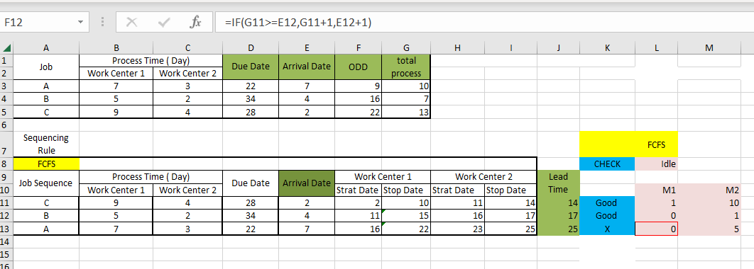

*Table 2.1*

Calculating the start date of job sequence, A and the start of Work Center 2 is done by adding processing time and arrival time, then subtracting by 1. This is followed by all three job sequences for both stations, with the lead time always equal to the Stop Date of Work Center 2 which is shown in Table 2.2.

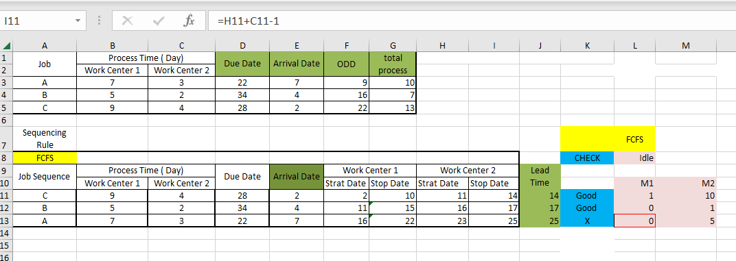

*Table 2.2*

The most important details in Table 2.3 are the calculation in the "CHECK" column, which shows that the stop date of Work Center 2 should be less than the Due date to meet the requirements and if the due date is smaller than the start date, it does not meet the delivery requirements. In the check column, Job A is indicated as cross "X".

*Table 2.3*

The idle time for Machine 1 and Machine 2 needs to be calculated by subtracting the start date of the work center 1 by 1. This will find the idle time of Machine 1 of Job sequence C, which is the first job sequence in Table 2.4.

*Table 2.4*

But to find the ideal time of Machine 1 of Job sequence B, as shown in Table 2.5, the start date of Work Center 1 is subtracted by the previous stop date of Work Center 1 and again subtracted by 1, i.e., 11-10-1 in this case. A similar method for calculations of further idle time of Machine 1s. Also, the same method is followed for the calculation of the Idle time of Machine 2s.

*Table 2.5*

The Total Lead Time for M1 is calculated by Subtracting the Final Stop Date of Work Center 1 from the initial Start Date of Work Center 1 and then adding 1 to the result which is shown in Table 2.6. Similarly, for M2 the Final Stop date of Work Center 2 IS subtracted by the Initial Start date of Work Center 1 subtracted by 1, which means from the table below, it will be calculated with the formula (=I13-F11+1).

*Table 2.6*

The Total Ideal Time for M1 is calculated by adding all the values of the Idle column of M1, that is, L11 + L12 + L12 which is shown in Table 2.7. Similarly, for Total Ideal Time for M2 all the values of the Idle column of M2 should be added, i.e., M11 + M12 + M13.

*Table 2.7*

Finally, the Running Time for M1 is calculated by adding all the Process Times of Work Center 1, i.e., =Sum (B11:B13) which has been shown in Table 2.8. Similarly, for M2, it should be the addition of all the Process Times of Work Center 2, i.e., =Sum (C11:C13).

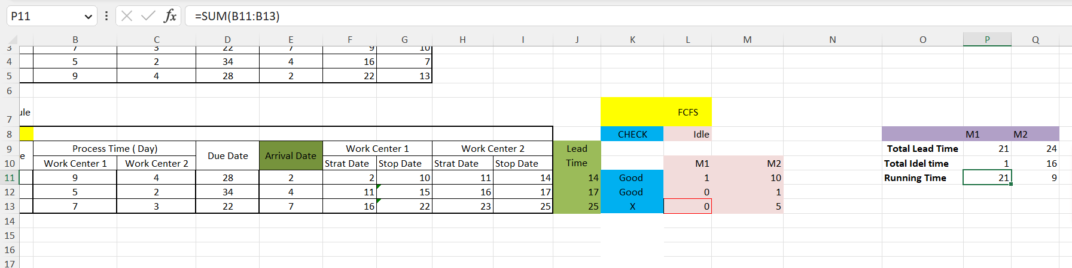

*Table 2.8*

**EDD:** In the second sequencing rule, EDD (earliest due date), the jobs are sequenced based on their due dates. Job A has the earliest due date, followed by Job C and then Job B. This can be seen in Table 3.

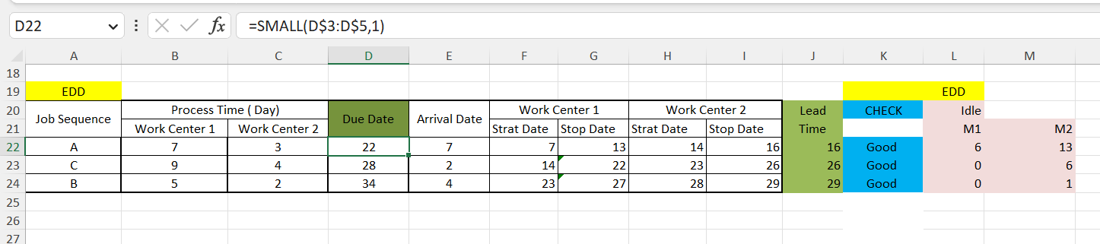

*Table 3*

The start and stop dates for each job in each work center are calculated based on the processing time, arrival date, and previous job's stop date. For example, the start date for work center 1 for job A is equal to the arrival date of job A. This applies for only the first start date of the table and for the second job sequence we use a different formula which is: =IF (Previous job sequence stop date>=current job arrival date, previous job sequence stop date + 1, current job sequence arrival date + 1) as shown in Table 3.1.

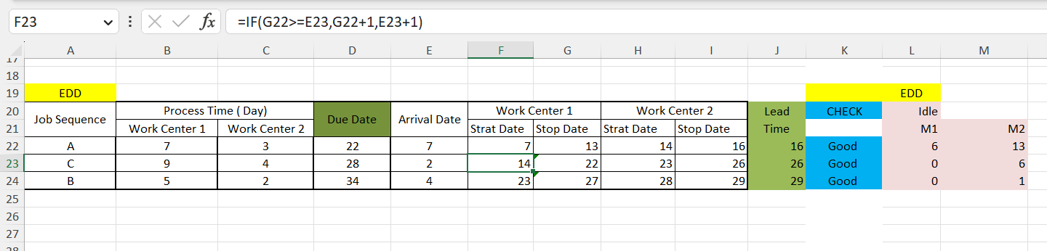

*Table 3.1*

We calculate the start date of job sequence B also similarly and the start of Work Center 2 is also calculated similarly to Work Center 1. Whereas the stop date is calculated by adding the processing time and arrival time and then subtracting by 1. This is followed by all three job sequences for both stations as shown in Table 3.2. The lead time is always equal to the Stop Date of Work Center 2, which we also can see in Table 3.2.

*Table 3.2*

In Table 3.3 we can see the calculation in the CHECK column. The stop date of Work Center 2 should be less than the Due date to meet the requirements and if the due date is smaller than the stop date of work center 2, it does not fulfill the delivery requirements. In this way CHECK for Sequence A is “Good”.

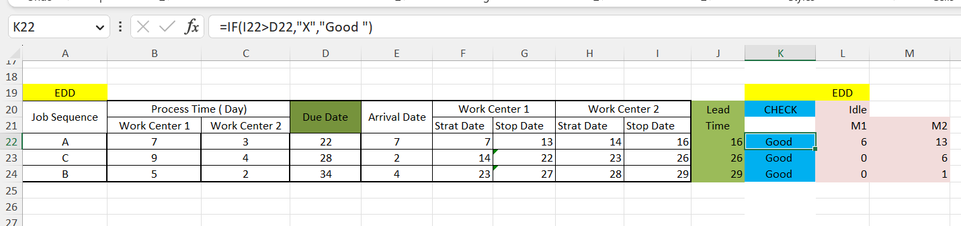

*Table 3.3*

As shown in Table 3.4 below, to find the idle time of Machine 1 of Job sequence A which is the first job sequence in the table, the start date of work center 1 is subtracted by 1. The idle time of job sequence A in Machine 2 is also calculated in the same way by subtracting the start date of work center 2 by 1.

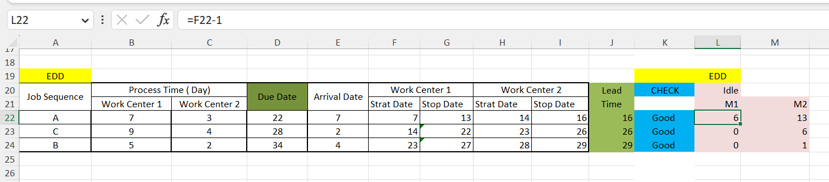

*Table 3.4*

But to find the ideal time of Machine 1 of Job sequence C, as shown in Table 3.5, the start date of Work Center 1 is subtracted by the previous stop date of Work Center 1 and again subtracted by 1, i.e., 14-13-1 in this case. A similar method for calculations of further idle time of Machine 1s. Also, the same method is followed for the calculation of the Idle time of Machine 2s.

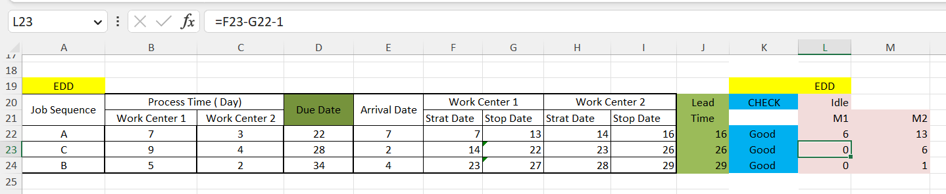*Table 3.5*

The Total Lead Time for M1 is calculated by 27-7-1 = 19 which is shown in Table 3.6. Similarly, for M2, the Final Stop date of Work Center 2 is subtracted by the Initial Start date of Work Center 1 subtracted by 1, i.e., 29-7-1 = 21.

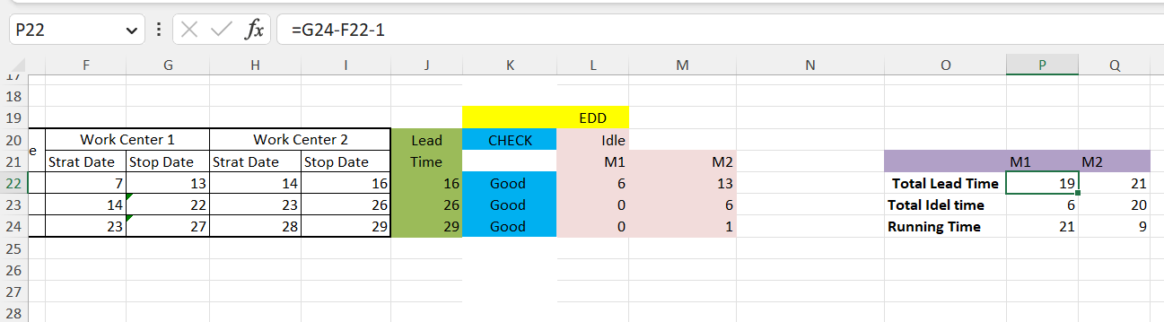

*Table 3.6*

The Total Ideal Time for M1 is calculated by 6+0+0 = 6 which is shown in Table 3.7. Similarly, the Total Ideal Time for M2 is calculated by 13+6+1 = 20.

*Table 3.7*

Finally, the Running Time for M1, 7+9+5 = 21 which has been shown in Table 3.8. Similarly, for M2, 3+4+2 = 9.

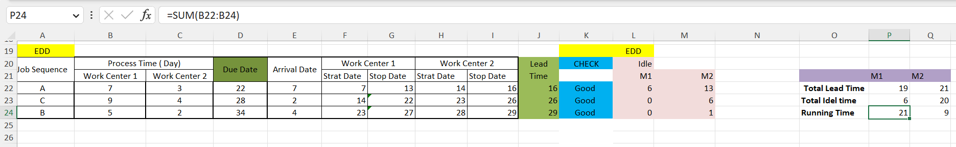

*Table 3.8*

**SPT:** In the fourth sequencing rule, SPT (shortest processing time), the jobs are sequenced based on their processing times. Job B has the shortest processing time, followed by Job A and then Job C as shown in Table 4.

*Table 4*

The Start date for B is the same as the Arrival date of B. But for A it is calculated using the formula =IF (Previous job sequence stop date>=current job arrival date, previous job sequence stop date + 1, current job sequence arrival date + 1) as shown in Table 4.1.

*Table 4.1*

We calculate the start date of job sequence C also similarly and the start of Work Center 2 is also calculated similarly to Work Center 1. Whereas the stop date is calculated by adding the processing time and arrival time and then subtracting by 1. This is followed by all three job sequences for both stations as shown in Table 4.2. The lead time is always equal to the Stop Date of Work Center 2, which we also can see in Table 4.2.

*Table 4.2*

In Table 4.3 we can see the calculation in the CHECK column. As per the formula in the formula bar, the CHECK for B is “Good”.

*Table 4.3*

As shown in Table 4.4 below, the idle time of Machine 1 of Job sequence A is (4-1 = 3). For Machine 2, it’s (9-1 = 8)

*Table 4.4*

But to find the ideal time of Machine 1 of Job sequence B, as shown in Table 4.5, it’s 9-8-1 in this case. A similar method for calculations of further idle time of Machine 1s. Also, the same method is followed for the calculation of the Idle time of Machine 2s.

*Table 4.5*

The Total Lead Time for M1 is calculated by 24-4-1 = 19 which is shown in Table 4.6. Similarly, for M2, the final Stop date of Work Center 2 is subtracted by the initial Start date of Work Center 1 subtracted by 1, i.e., 28-4-1 = 23.

*Table 4.6*

The Total Ideal Time for M1 is calculated by 3+0+0 = 3 which is shown in Table 4.7. Similarly, the Total Ideal Time for M2 is calculated by 8+5+6 = 19.

*Table 4.7*

Finally, the Running Time for M1, 5+7+9 = 21 which has been shown in Table 4.8. Similarly, for M2, 2+3+4 = 9

*Table 4.8*

# **Gantt Chart**

The Gantt chart is a visual representation of the scheduling of the three jobs, A, B, and C, at Work Center 1 and Work Center 2, using the different sequencing rules. The Gantt chart is created by customizing the stacked bar chart in Excel, with the x-axis representing time and the y-axis representing the work centers. The Gantt chart shows the start and stops times for each job at each work center, as well as any idle time. Each job is represented by a different color bar on the chart.

The Gantt chart provides a clear and easy-to-understand visualization of the production process, allowing production managers to quickly compare the different sequencing rules and identify which rule results in the most efficient production process. As we can see in Figure 1, there is a Gantt chart of FCFS, EDD, and SPT.

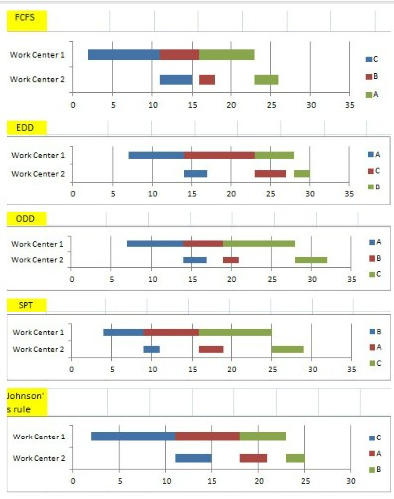

*Figure 1*

Based on the calculations and analysis performed using the FCFS, EDD, and SPT rules for dispatching jobs A, B, and C, it appears that the EDD rule is the most effective for these jobs. Firstly, it’s worth noting that the FCFS and SPT rules had some limitations when it comes to job scheduling. The FCFS rule schedules jobs in the order they are received, which may not necessarily result in optimal utilization of resources or meeting deadlines. The SPT rule prioritizes jobs based on the shortest processing time, but this may not always be the best approach in situations where some jobs are more urgent or have stricter deadlines. In contrast, the EDD rule prioritizes jobs based on their due dates, ensuring that jobs with earlier due dates are completed first. This can be particularly effective in situations where there are deadlines to be met or penalties for late completion of jobs. In the case of jobs, A, B, and C, all of them had due dates, and using the EDD rule ensured that they were completed in a timely manner.

Furthermore, when we looked at the status of each job after completion, we found that only the jobs completed using the EDD rule were considered “Good”. This suggests that the EDD rule was able to allocate resources more effectively, resulting in better outcomes for the jobs. Overall, based on the analysis and results obtained, it appears that the EDD rule is the most effective approach for dispatching jobs A, B, and C.

## **Conclusion**

In conclusion, this project explored the concept of job scheduling in a manufacturing environment. Three different dispatching rules, namely FCFS, EDD, and SPT, were used to schedule three jobs A, B, and C with different processing times and due dates.

The results of the analysis showed that the EDD rule was the most effective for these jobs, as it minimized the maximum lateness and ensured that all jobs were completed on time with a status of "Good". The FCFS and SPT rules had higher maximum lateness and caused each job to have a status of "X" which is considered as not effective one.

Overall, the project demonstrated the importance of selecting an appropriate dispatching rule to optimize job scheduling and minimize lateness. This can improve efficiency and productivity in a manufacturing environment, leading to higher customer satisfaction and profitability.

# **References**

Job Scheduling Presentation, Dr. Wang, and Dr. Scott – PowerPoint file.

Job Scheduling – Excel file

Optimum splitting o lots - Excel file